Size430ft² = 40m²
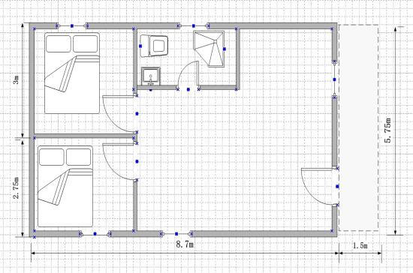
Size 538ft² = 50m²
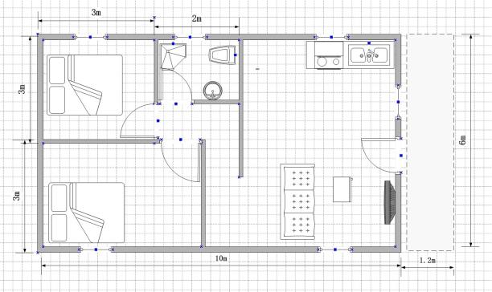
Size 647ft² = 60m²

